AT1 Portfolio

30003389 – Kyer Potts

Table of Contents

|  |  |  |  |
| --- | --- | --- | --- |
| Test Case | Data | Expected Result | Actual Result / Comment |
| Case 1 | num1 = 2  num2 = 5  num3 = 7 | 7 is largest  2 is lowest | Result as expected, code logic sound for input |
| Case 2 | num1 = 5  num2 = 3  num3 = 7 | 7 is largest  3 is lowest | Result as expected, code logic sound for input |
| Case 3 | num1 = 7  num2 = 5  num3 = 1 | 7 is largest  1 is lowest | Result as expected, code logic sound for input |
| Case 4 | num1 = 7  num2 = 5  num3 = 5 | 7 is largest  5 is smallest | Logic sound, num 2 and 3 have same value however else statement ensures that there is still result output for lowest value |
| Case 5 | num1 = 7  num2 = 7  num3 = 1 | 7 is largest  1 is smallest | No result, equal highest value numbers do not fit into the logic. 7 is not > than 7, so code ends when if statements return false. |
| Case 6 | num1 = 6  num2 = 6  num3 = 6 | No result | All if statements return false, no further code exectutes. |

# Question 1 Table

# Question 2 Chart

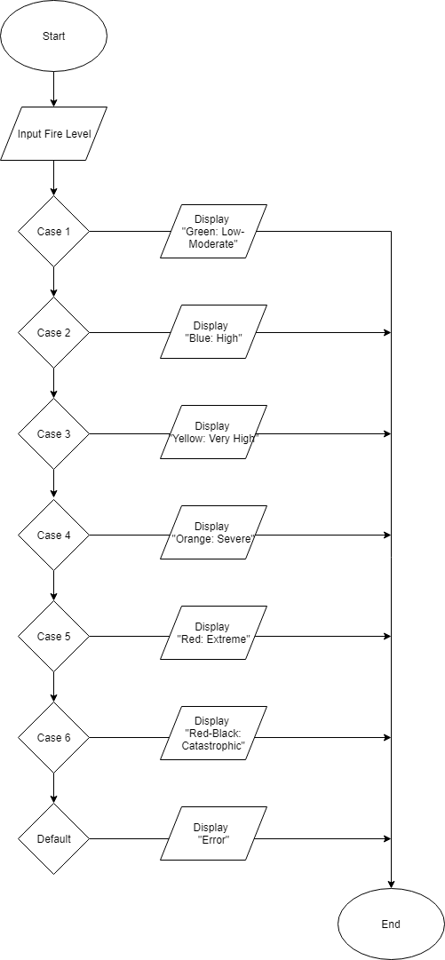

# Question 3 Table

|  |  |  |  |
| --- | --- | --- | --- |
| Test Case | Data | Expected Result | Actual Result |
| Case 1 | sentinel = true  counter = 19  minValue = 7 | Countdown from 19-7 | 19  18  17  16  15  14  13  12  11  10  9  8  7 |
| Case 2 | sentinel = true  counter = 7  minValue = 19 | Values are false | No bueno |
| Case 3 | sentinel = false  counter = 19  minValue = 7 | Values are false | No bueno |
| Case 4 | sentinel = true  counter = 7  minValue = 7 | Displays single value of 7 as 7 is >= to 7. Loop runs once, outputs value and then ends. | 7 |

# Question 4 Chart

